**PACIFIC LIBRARY MANAGEMENT SYSTEM USER MANUAL.**

* This is a system designed to help automate and make the management of library resources easier. It is main use is to keep the necessary records of books and library members and also handle the borrowing of books.
* This system helps save time, money and resources that would else be used to manually do the tasks automated by this system like updating and storing records. This system ensures that the library uses the least resources and still remains lucrative.
* To use this system, a **Master Admin** must be created first**.** The master admin is created to authorize creation of other admins who operate the system. **The master can on be created once.** They cannot not perform operations like book check-in or out, they only oversee the admins; edit or delete admins.
* The master admin is created once the program is open for the first time, the other buttons are disabled since the master admin does not exist as seen below

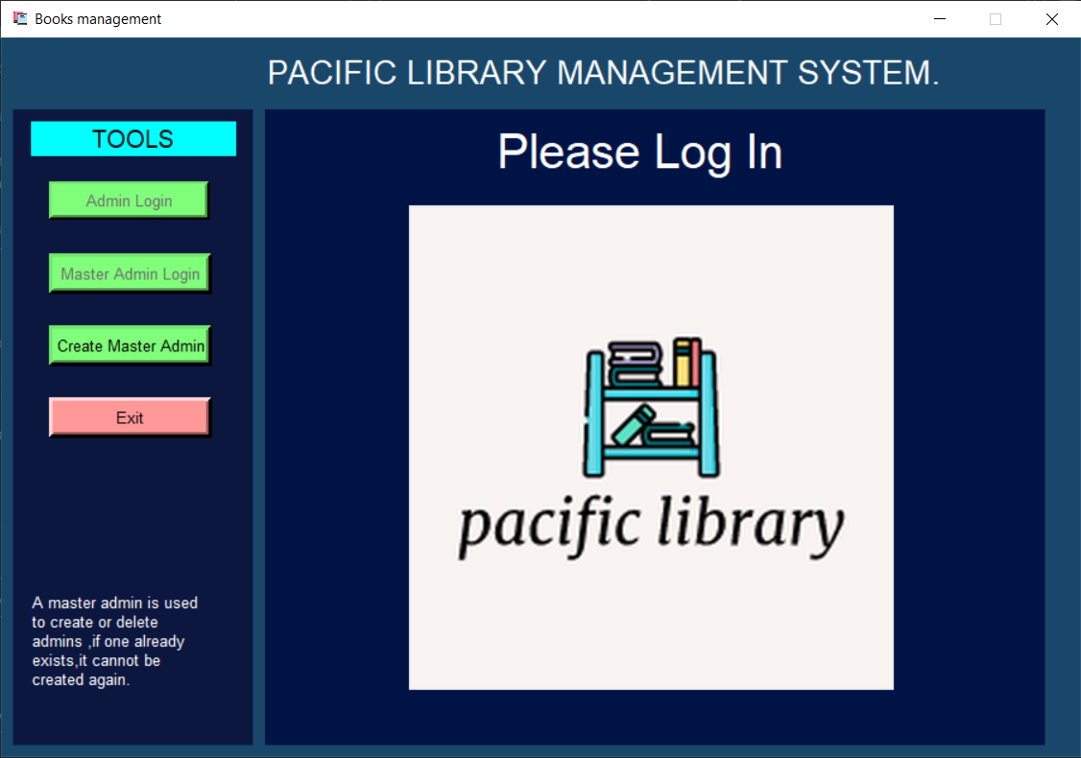

* To create a master admin, click the *Create Master Admin* button and you will be redirected to the page below, there you will fill in the form to create a master admin.

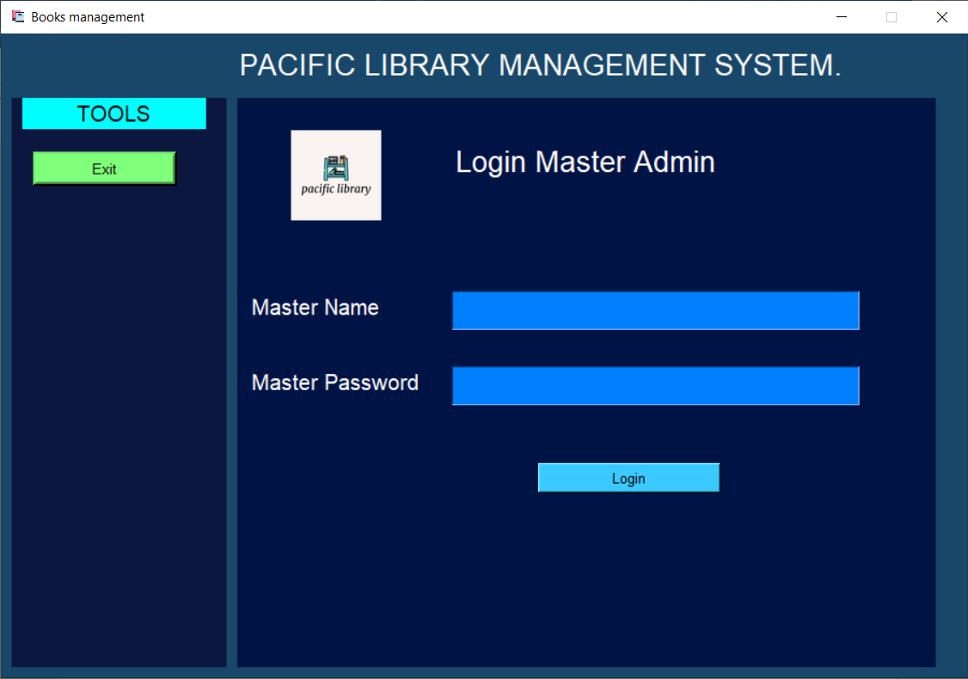

**There can only be one master admin.**

Creation

Of

Master

Admin

* After a successful creation of a master admin, you will be directed to **log in the master admin.**

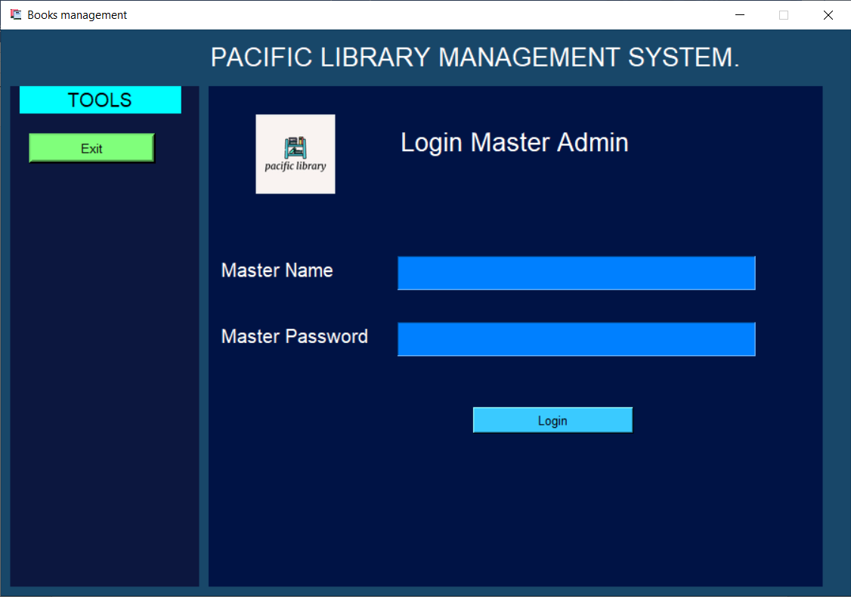

* Log in the master admin.
* After logging in, the master admin menu will open, here click the ***Create Admin*** button and create an admin.
* You can always create other admins later.

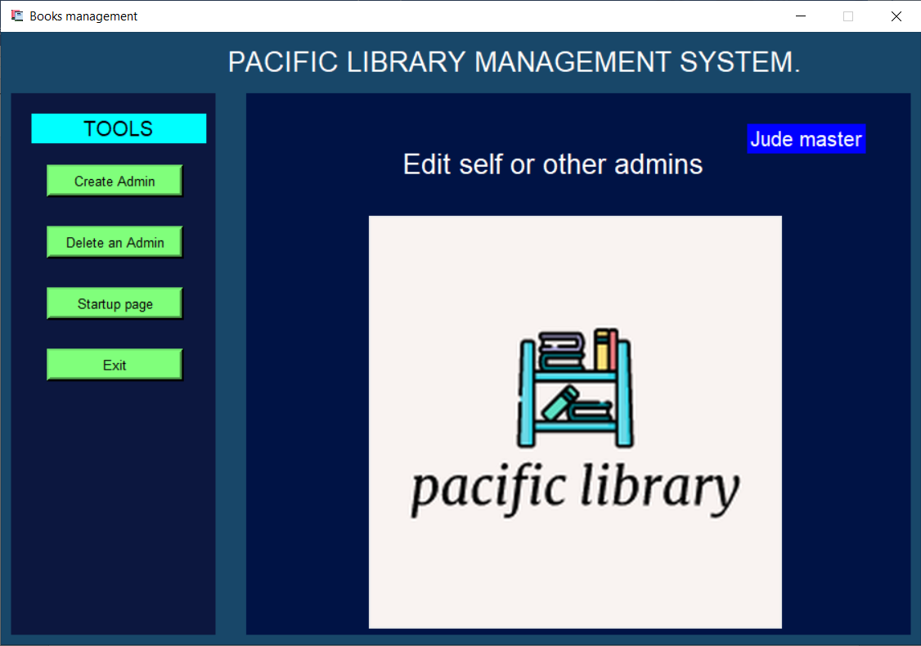

* The admin creation well be as below.

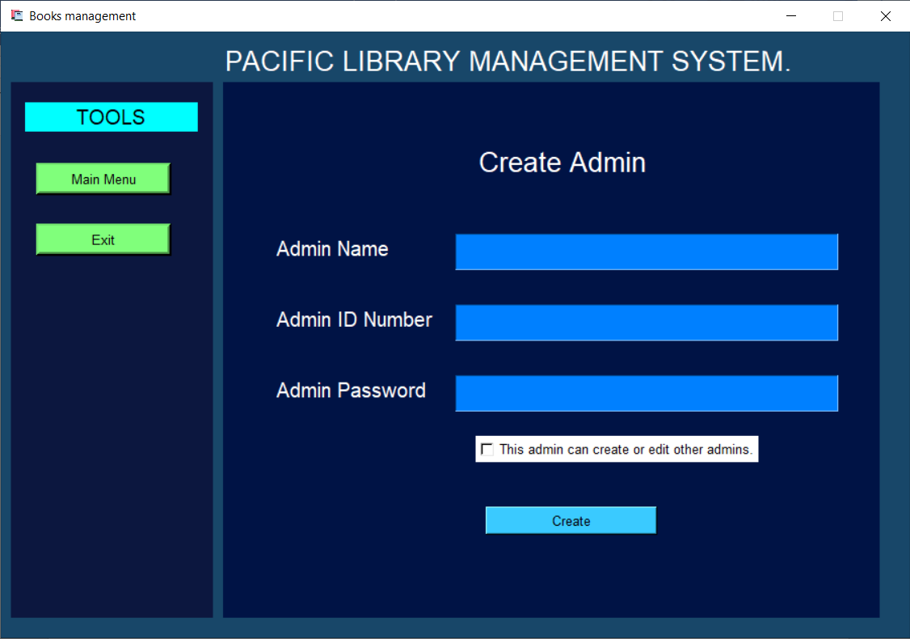

Creation

Of

Admin

* Fill in the form to create and admin. **To give the admin the right to create other admins, check the checkbox.**
* After creating the admin, you will be redirected to the startup page where you can log in the admin.
* In the startup page, log in the admin and after that the admin menu page will open where the admin can perform library operations which include:

1. **Members management**

* Registering new members.
* Editing members.
* Deleting member

1. **Books management.**

* Adding a book.
* Editing a book.
* Deleting a book.
* Viewing a book.

1. **Book check in or out.**

* Borrow a book.
* Return a book
* The admin menu page look like this:

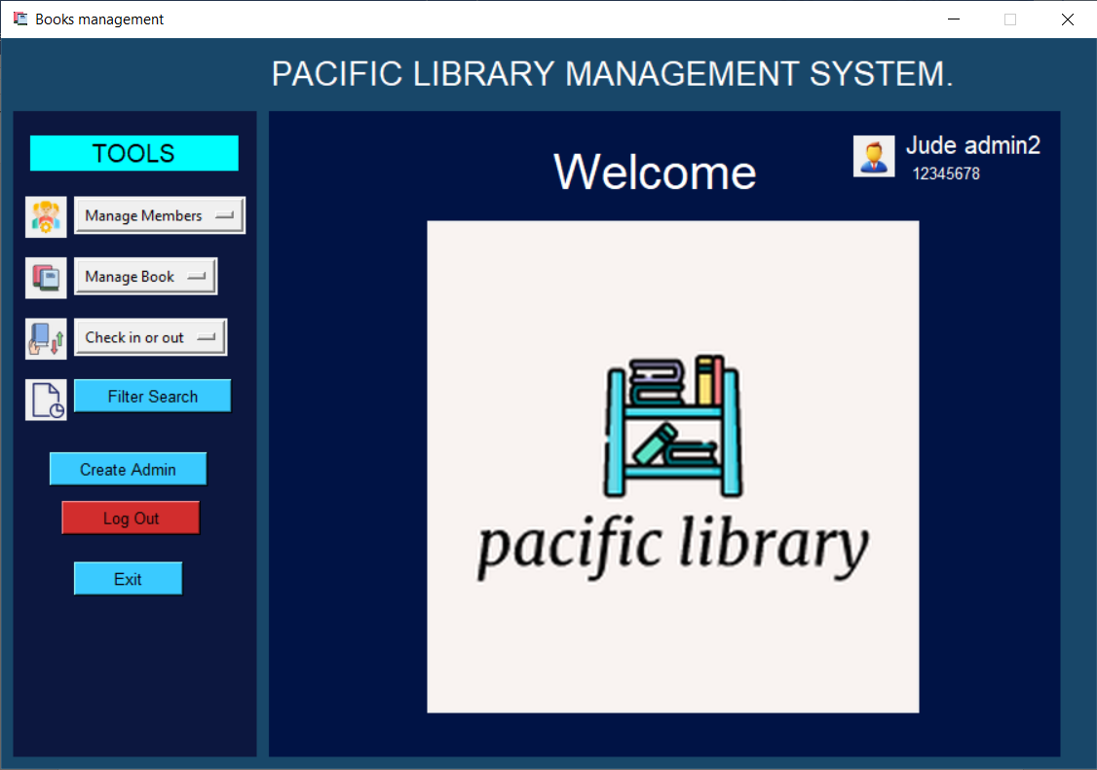

The drop-down buttons will the options discussed above.

Shows the currently logged in Admin’s ID and name.

* The logged admin in can also use the ***Filter search*** button to search for records using various criteria.
* Finally, an admin can log out or exit the program.

**Other features**

* Every time the program is opened (assuming it is opened daily), it auto checks for overdue books and adds the overdue members and their necessary information to a different table. When this is done, an admin can then send SMS messages to the overdue members using the number they used to sign up and remind them to return the book and also their fine.

**Developer Instructions**

* The program is made using python 3 and for GUI it uses python’s library tkinter.
* It uses sqlite3 to store data.

**NB:**

* The program uses SMS messaging which might be slow when sending to a lot of people. A bulk email service is recommended.
* All the code for the whole program is in one file ***app.py.***
* The file ***funcs.py*** has functions for the table creations and deletion, It possible to manipulate the database using the functions in this file.